**IFT 266 Introduction to Network Information Communication Technology (ICT)   
  
Lab 33**

**Using the CLI to Create IPV6 Link-Local, GUA’s, Subnets, and Auto Configure their PC’s**Co-authored by Paul Polsinelli

Choose from the list of commands from the bottom of the page and put them in the right order by typing them in the proper box.

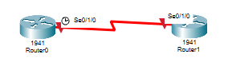

1. Enable ipv6 unicast-routing and link-local addresses on two router serial connections.

**Router0**

Router>

Router#

Router (config)#

Router (config)#

Router (config-if)#

Router (config-if)#

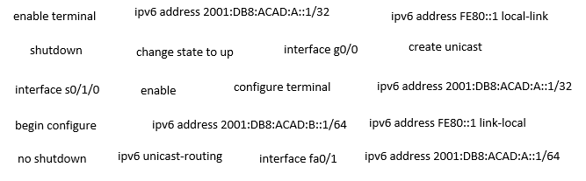

**Router1**

Router>

Router#

Router (config)#

Router (config)#

Router (config-if)#

Router (config-if)#



1. Create the topology in packet tracer and input the commands you selected above.   
     
   Your topology should now look like the following image

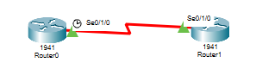





1. We will now add 2 switches and 2 PCs to our topology.

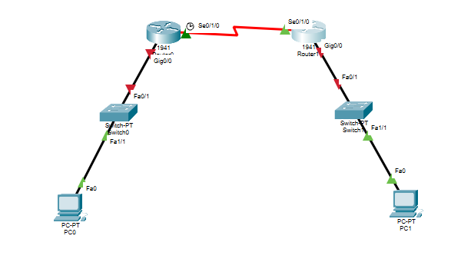



1. Enable ipv6 link-local addresses on two router gigabit connections.

**Router0**

Router>

Router#

Router (config)#

Router (config-if)#

Router (config-if)#



**Router1**

Router>

Router#

Router (config)#

Router (config-if)#

Router (config-if)#



1. Input the commands in packet tracer.



1. Your topology should now look like the following image.

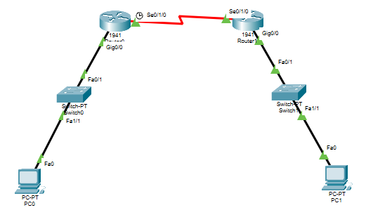



1. Now we will configure the routers with Global Unicast Addresses (GUA)s.

**Router0**

Router>

Router#

Router (config)#

Router (config-if)#

Router (config-if)#



**Router1**

Router>

Router#

Router (config)#

Router (config-if)#

Router (config-if)#



1. Input the commands in packet tracer.



1. You should now be able to Auto Config the PC’s.   
     
   The fields IPv6 Address, Link Local Address, and IPv6 Gateway should automatically populate.   
     
   Do this autoconfiguration for PC1, then take a screenshot and insert below.